CPE301 – SPRING 2019

Design Assignment 2A

Student Name: Meral Abu-Jaser

Student #: 5003137888

Student Email: abujaser@unlv.nevada.edu

Primary Github address: <https://github.com/MeralAbuJaser/Submission_da.git>

Directory:

1. **COMPONENTS LIST AND CONNECTION BLOCK DIAGRAM w/ PINS**

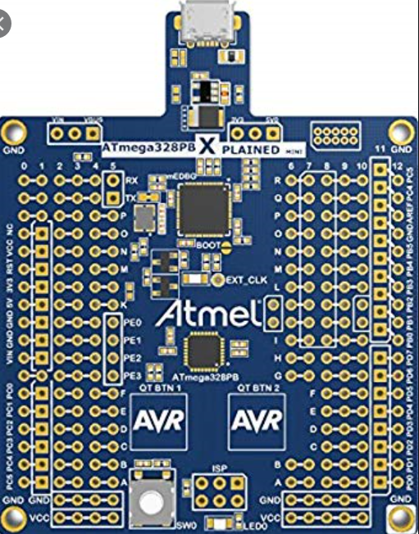 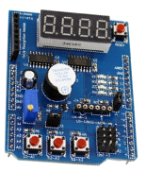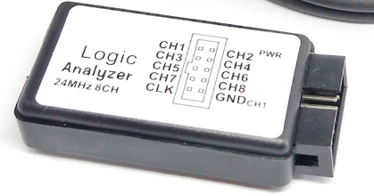

Atmel Studio 7.0

-debugger

-simulator

-assembler

Atmega 328pb Sheild logic analizer

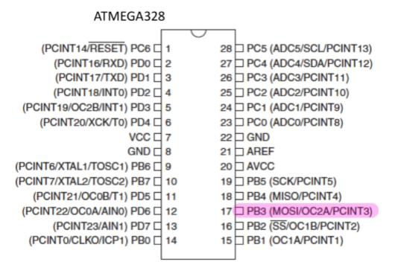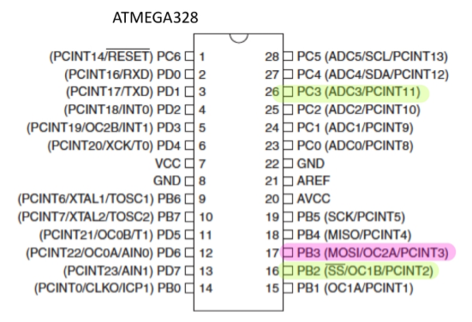

Part 1 using pin PB3 Part 2 using pins PC3, PB3, PB2

1. **INITIAL/MODIFIED/DEVELOPED CODE OF TASK 1/A**

C code

#include <avr/io.h>

#define F_CPU 16000000UL

#include <util/delay.h>

int main(void){

DDRB |= (1<<PB3); //making portb.3 output

while(1){

PORTB |= (1<<PB3); //output "LED ON"

_delay_ms(412.5); //delay for 412.5ms @16MHz

PORTB &= ~(1<<PB3); //output "LED OFF"

_delay_ms(337.5); //delay for 375.5ms @16MHz

}

return 1;

}

Assembly code

DUTY_CYCLE:

SBI DDRB, 3 //portb output

SBI PORTB, 3 //turn on PortB.3

LDI R18, 31 //loading for delay

LDI R19, 65 //

LDI R20, 90 //

CALL DELAY337 //calling delay for 337

CBI PORTB, 3 //turn "OFF" PortB.3

LDI R21, 31 //loading for delay

LDI R22, 113

LDI R23, 31

CALL DELAY412

JMP DUTY_CYCLE //jump to duty cycle

DELAY337: //delay 337

DEC r20

BRNE DELAY337

DEC r19

BRNE DELAY337

DEC r18

BRNE DELAY337

NOP

RET

DELAY412: //delay 412

DEC r23

BRNE DELAY412

DEC r22

BRNE DELAY412

DEC r21

BRNE DELAY412

NOP

RET

1. **DEVELOPED MODIFIED CODE OF TASK 2/A from TASK 1/A**

C code

#include <avr/io.h>

#define F_CPU 16000000UL

#include <util/delay.h>

int main(void){

DDRB |= (1 << 3); //making portb.3 output

PORTB &= ~(1 << 3); //making portb.3 output "OFF"

DDRC &= ~(1 << 3); //making portc.3 input

PORTC |= (1 << 3); //pull up resistor activated pinc.3

while (1){

PORTB |=(1<<3); //output "LED ON"

_delay_ms(412); //delay for 250ms @16MHz

PORTB &=~(1<<3); //output 'LED OFF"

_delay_ms(337); //delay for 375ms @16MHz

if (!(PINC & (1 << 3))){

DDRB &=~(1<<3); //making portb.3 output "LED OFF"

DDRB |=(1<<2); //making portb.2 output "LED ON"

_delay_ms(2000); //delay for 2 seconds

DDRB &=~(1<<2); //making portb.2 output "LED OFF"

DDRB |=(1<<3); //making portb.3 output "ON"

}

}

return 1;

}

Assembly code

.ORG 0

CBI ddrc, 3 //set bit 3 in port c for input

SBI portc, 3 //PortC.3 is set to take in input

SBI ddrb, 2 // set bit 2 in port b for output

CBI portb, 2 // PortB.2 is off

LOOP:

SBI DDRB, 3 //portb output

SBI PORTB, 3 //turn on PortB.3

LDI R18, 31 //loading for delay

LDI R19, 65 //

LDI R20, 90 //

CALL DELAY337 //calling delay for 337

CBI PORTB, 3 //turn "OFF" PortB.3

LDI R21, 31 //loading for delay 412

LDI R22, 113

LDI R23, 31

CALL DELAY412 //calling for delay

SBIC pinc, 3 //if Pinc.3 is clear, skip next

JMP LOOP //button is not pressed, loop back

CBI PORTB, 2

CALL DELAY200 // wait for 2 seconds

SBI portb, 2 // PortB.2 is turned on after the delay

JMP LOOP // loop back and check for button press

DELAY200: // Delay for 2 seconds

LDI r18, 164

LDI r19, 255

LDI r20, 200

again:

DEC r20

BRNE again

DEC r19

BRNE again

DEC r18

BRNE again

RET

DELAY337: //delay 337

DEC r20

BRNE DELAY337

DEC r19

BRNE DELAY337

DEC r18

BRNE DELAY337

NOP

RET

DELAY412: //delay 412

DEC r23

BRNE DELAY412

DEC r22

BRNE DELAY412

DEC r21

BRNE DELAY412

NOP

RET

1. **SCHEMATICS**

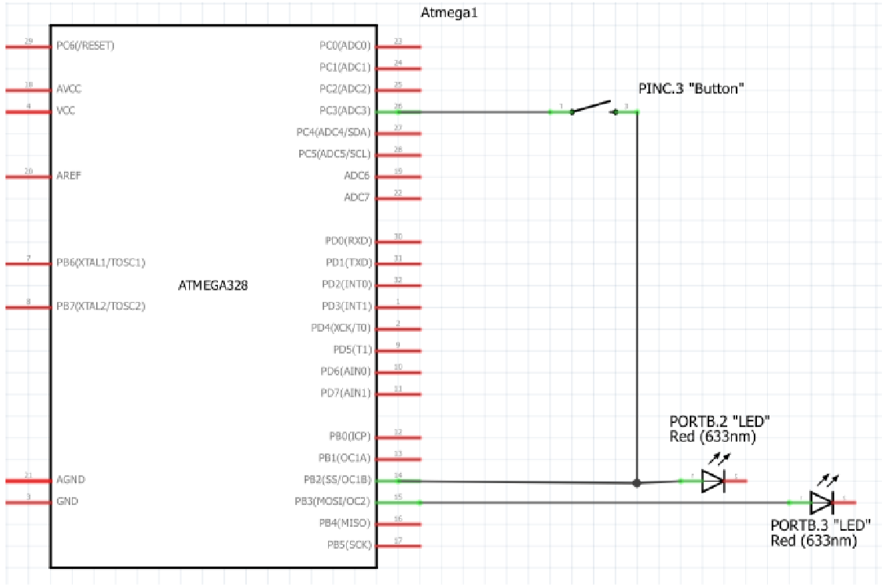

1. **SCREENSHOTS OF EACH TASK OUTPUT (ATMEL STUDIO OUTPUT)**

N/A

1. **SCREENSHOT OF EACH DEMO (BOARD SETUP)**

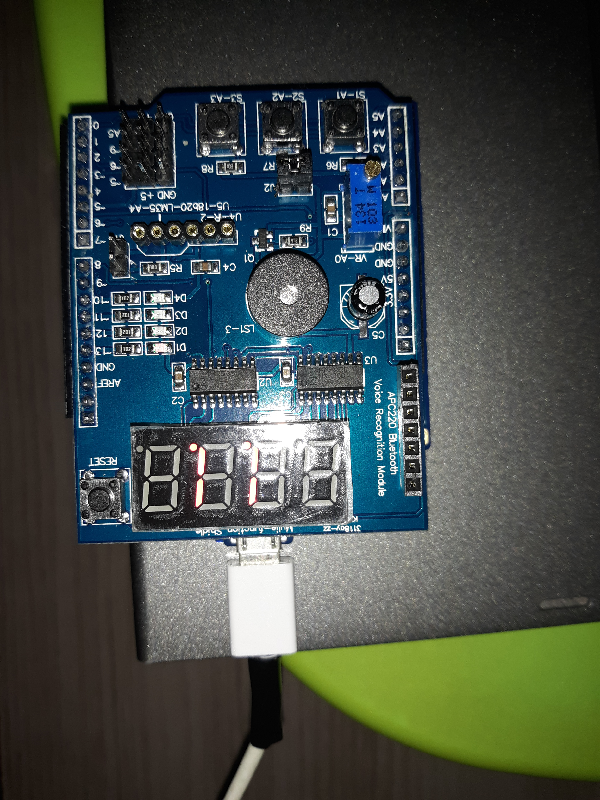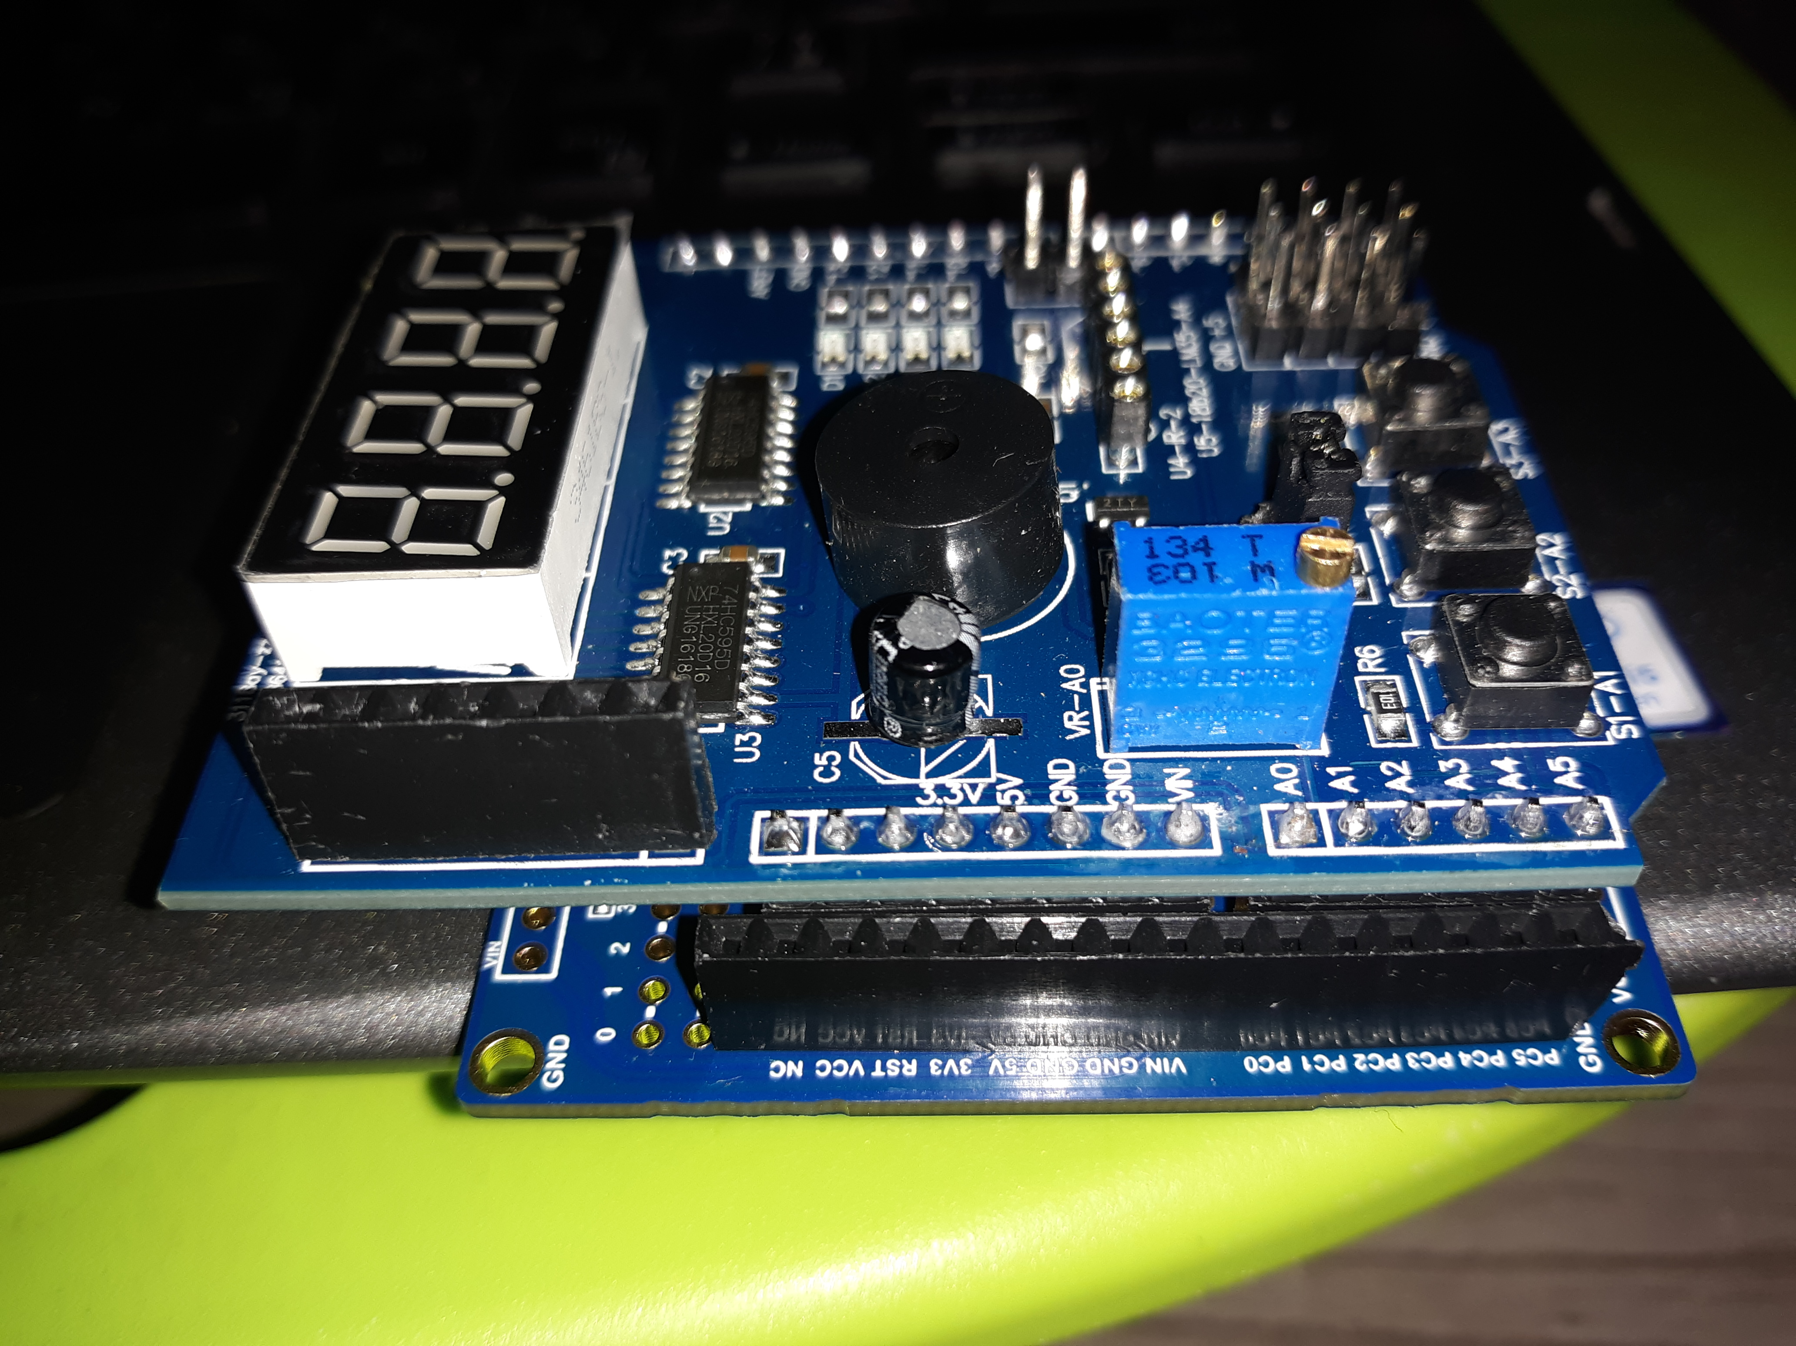

1. **VIDEO LINKS OF EACH DEMO**

Task 1

<https://www.youtube.com/watch?v=0o3QuOS7vuI>

Task 2

<https://www.youtube.com/watch?v=tDFLxxQDV7c>

1. **GITHUB LINK OF THIS DA**

<https://github.com/MeralAbuJaser/Submission_da/tree/master/Assignment1B>

“This assignment submission is my own, original work”.